Comment on Boger & Firestone (2026): Perceiving animacy in ‘identical’ images
  - Surya Gayet
Helmholtz Institute, Utrecht University, Experimental Psychology, Utrecht, The Netherlands
Correspondence: s.gayet@uu.nl
ORCID: 0000-0001-9728-1272

Abstract
Boger and Firestone (2026) use a novel set of hybrid stimuli whose identity changes with rotation. They find that change-detection is easier when such images cross the animate-inanimate boundary, and that targets are found faster among distractors of the opposite animacy, despite these objects being constituted of the same pixel-by-pixel content. These results are taken as evidence that animacy influences visual cognition independently of its lower-level visual correlates. Here, I challenge this inference on two grounds. First, rotation preserves global image statistics but changes the positions and orientations of local features in a retinotopic, anisotropic visual system. Second, findings obtained with a small set of deliberately ambiguous images do not establish the mechanisms of ordinary object recognition. Visual anagrams are ingenious stimuli, but their usefulness for isolating animacy from its visual correlates remains limited.

Main manuscript

A novel way of controlling for stimulus content
Boger and Firestone (2026) introduce an ingenious way to investigate visual object processing, separately from the object’s visual stimulus characteristics. In a series of pre-registered behavioral experiments, they study the processing of animacy using visual anagrams. These are carefully crafted images that depict an animal in one orientation and an inanimate object in another: a dog is rotated by 90 degrees to become a boot, and an elephant becomes a sofa (Figure 1). These images produced consistent animacy-specific behavioral effects depending on their orientations, despite the pixel-wise information remaining identical between animacy conditions: In a change-detection task, observers more accurately detected object replacements that changed animacy compared to replacements that did not; in visual search, participants more quickly found targets among distractors of the opposite compared to the same animacy category. Control experiments showed that these effects did not persist for convex-hull silhouettes, which preserve the global shapes of the visual anagrams but are no longer recognizable. This is taken as evidence that the observed effects are not driven by differences in overall stimulus orientation per se, but are driven by the perception of animacy. The animacy effects also did not replicate when using written words instead of visual objects in the search task, showing that the animacy correspondence was driven by genuine visual animacy perception rather than through semantic matching or linguistic labelling. Eventually, the authors conclude that their approach isolates animacy from its visual correlates, thereby demonstrating that animacy directly impacts visual cognition.
While the stimuli and experimental designs are inventive, and the behavioral effects are clear, I here highlight two main limitations that undermine the key theoretical conclusions. Firstly, while rotating an image is an effective way to preserve some (global) visual properties, it does not preserve visual characteristics as represented at the level of early (retinotopic) visual processing regions. Thus, despite their best efforts to equate visual stimulus characteristics between conditions in a pixel-wise manner, animate and inanimate objects vastly differed in visual stimulus content from the earliest stages of the human visual processing stream onwards. Secondly, pictures deliberately engineered to support incompatible identities may be considerably harder to identify than ordinary objects (see Figure 1). How observers solve these visual puzzles need not reflect how they typically recognize objects.

Same pixels, different visual input
Image rotation is often used as control in studies using naturalistic stimuli, as it preserves many visual characteristics (which may drive behavioral and brain responses) while severely impacting the extraction of meaning from the image (Jolicoeur, 1985; Lawson, & Jolicoeur, 1998). Indeed, rotation preserves such global stimulus properties as stimulus curvature, which is known to partially drive animacy responses (Levin, Takarae, & Miner, 2001; Long, Störmer, & Alvarez, 2017; Yetter, Robert, Mammarella, Richmond, Eldridge, Ungerleider, & Yue, 2021), as well as mean luminance, RMS contrast, and the radially averaged spatial-frequency spectrum. However, as the image rotates, the canonical shape of the image is altered, edge orientation changes, and local features change retinal position. This is important, because the earliest stages of the visual processing stream are characterized by cells that are both position and feature selective. The same edge that was vertical and in the left hemifield in one version of the visual anagram, can be horizontal and in the upper hemifield in the other version, thereby activating different neurons in the lateral geniculate nucleus (Cheong, Tailby, Solomon, & Martin, 2013; Schneider, Richter, & Kastner, 2004), the striate and extra-striate visual cortex (Hubel & Wiesel, 1968; Levitt, Kiper, & Movshon, 1994), and even differentially activating orientation-dependent retinal ganglion cells (Passaglia, Troy, Rüttiger, & Lee, 2002). Thus, while visual anagrams preserve the pixel-wise output of the stimuli across animate and inanimate stimuli on the screen, the visual information provided by both variants of a visual anagram vastly differs from the retinae onwards and throughout all stages of visual analysis in the brain.
Going beyond differences in local stimulus features, rotation also changes global stimulus properties. The same elongated object may span the upper and lower hemifields in one configuration, and the left and right hemifields in the other. This has implications for the earliest stages of visual processing onwards, because the visual field is not sampled uniformly. At matched eccentricity, acuity is generally better along the horizontal than vertical meridian, and along the lower compared to upper meridian (Barbot, Xue, & Carrasco, 2021), corresponding to variations in V1 cortical magnification around the visual field (Benson, Kupers, Barbot, Carrasco, & Winawer, 2021), and potentially even to differences in retinal sampling (Kupers, Benson, Carrasco, & Winawer, 2022). Moreover, different parts of the visual field are also differentially sensitive to specific visual features. Orientation preferences considerably vary across the visual field (Sasaki, Rajimehr, Kim, Ekstrom, Vanduffel, & Tootell, 2006; Roth, Kay, & Merriam, 2022). Such visual field location-specific selectivity is even observed for object-level visual content: images of isolated eyes and mouths are recognized better, and their neural representations are more discriminable, at their typical (i.e., upper- and lower) visual field locations (de Haas, Schwarzkopf, Alvarez, Lawson, Henriksson, Kriegeskorte, & Rees, 2016). Thus, spatial heterogeneity extends from retinal sampling to cortical feature selectivity. Rotating an image thus drastically alters how it is processed from the retinae onwards.
Experiment 7 directly addresses global image orientation as a possible confound. This control experiment shows that animacy-like effect do not replicate when the visual anagrams are replaced by convex-hull silhouettes that hamper the extraction of animacy while preserving their spatial layout. However, these findings merely show that global shape alone is not sufficient for the visual anagrams to be processed as animate versus inanimate. It does not exclude the possibility that the difference between animate and inanimate variants of the visual anagrams observed in the other experiments was caused by differences in visual characteristic brought about by image rotation.
Taken together, rotation of the visual anagrams inevitably creates differences in visual image characteristics at all levels of the visual processing hierarchy, which are not necessarily less distinct than responses produced by two different source images from the animate and inanimate conditions.

From solving visual puzzles to regular object perception
A second concern pertains to the generalizability of object recognition with visual anagrams compared to regular objects. Firstly, generalizability is limited by the small stimulus set, which comprised only six visual-anagram pairs. Rather than reflecting a category-level effect of animacy, the aggregate results could therefore be driven disproportionately by one or two idiosyncratic pairs (Wells, & Windschitl, 1999; Judd, Westfall, & Kenny, 2012; Westfall, Judd, & Kenny, 2015; Yarkoni, 2022). This concern is amplified for complex naturalistic images, which contain substantial image-level variation (Coggan et al., 2019).
More fundamentally, however, it also remains unclear whether visual anagrams engage the same recognition processes as ordinary objects. Visual anagrams are unusual by construction: the same features are shaped to support two incompatible readings of the image. Even successful recognition of ambiguous or impoverished images has been shown to involve different temporal dynamics, and a greater contribution from prior knowledge and recurrent processing, compared to recognition of unambiguous images (Flounders, González-García, Hardstone, & He, 2019; Tang, Buia, Madhavan, Crone, Madsen, Anderson, & Kreiman, 2014; Rajaei, Mohsenzadeh, Ebrahimpour, & Khaligh-Razavi, 2019), with recognition processes strongly varying as a function of the degree or type of ambiguity (Linde-Domingo, Ortiz-Tudela, Völler, Hebart, & González-García, 2026).
These findings raise the possibility that extracting an identity from the current set of visual anagrams prompts highly atypical recognition processes. Without directly comparing such factors as recognition dynamics and representational content with those evoked by ordinary object images, generalization from these visual anagrams to typical animacy processing remains premature; a problem that is further exacerbated by the small number of exemplars used in this study.

Moving forward
Converging evidence from complementary methods is essential, and the search for novel ways to address longstanding methodological problems is laudable. Image inversion has often proven to be a useful control condition precisely because it preserves many visual properties while disrupting the extraction of meaning, even though it does not control for all differences in visual processing. Visual anagrams inherit this limitation: because rotation changes the orientations and retinotopic positions of local features, the two variants may pragmatically be regarded as different visual stimuli, whose post-rotation visual characteristics can systematically covary with animacy (Boger & Firestone, 2026), real-world size (Boger, & Firestone, 2025), or other higher-level properties, just as they would across two distinct image sets. Moreover, whereas standard inversion paradigms preserve a recognizable, intact image in the upright condition, visual anagrams degrade even the ‘intact’ images, increasing ambiguity and hampering recognizability without necessarily providing a stronger control over the visual input (except perhaps for global effects of curvature).
Various methods address these problems through different trade-offs. Binocular rivalry or spatial-frequency hybrid images would allow to keep retinal stimulation actually identical across perceptual outcomes, although they may also evoke ambiguous percepts; in contrast, representational similarity analysis (Kriegeskorte, Mur, & Bandettini, 2008) would allow presenting ordinary naturalistic images, while separating animacy-related representations from their low- and mid-level visual correlates analytically (e.g., Proklova, Kaiser, & Peelen, 2016). Neither of these routes is necessarily superior to the other. However, compared with analytic approaches and inversion conditions, visual anagrams sacrifice the naturalism of ordinary images; and compared with binocular rivalry or hybrid images, they fail to preserve the visual input constant across conditions. Thus, it remains unclear what unique information visual anagrams could contribute to the converging evidence provided by existing methods.

Conclusion
Taken together, because rotation fundamentally alters the visual input reaching the visual system, visual anagrams do not clearly provide stronger control over visual correlates than conventional rotation or inversion conditions; and because their deliberately ambiguous and degraded content may recruit recognition processes that differ from those engaged by ordinary objects, their findings have limited generalizability to real-world object recognition. Thus, while visual anagrams are inventive (and admittedly nice for on a coaster), their value as a general solution to isolating higher-order concepts from their lower level visual correlates remains limited.

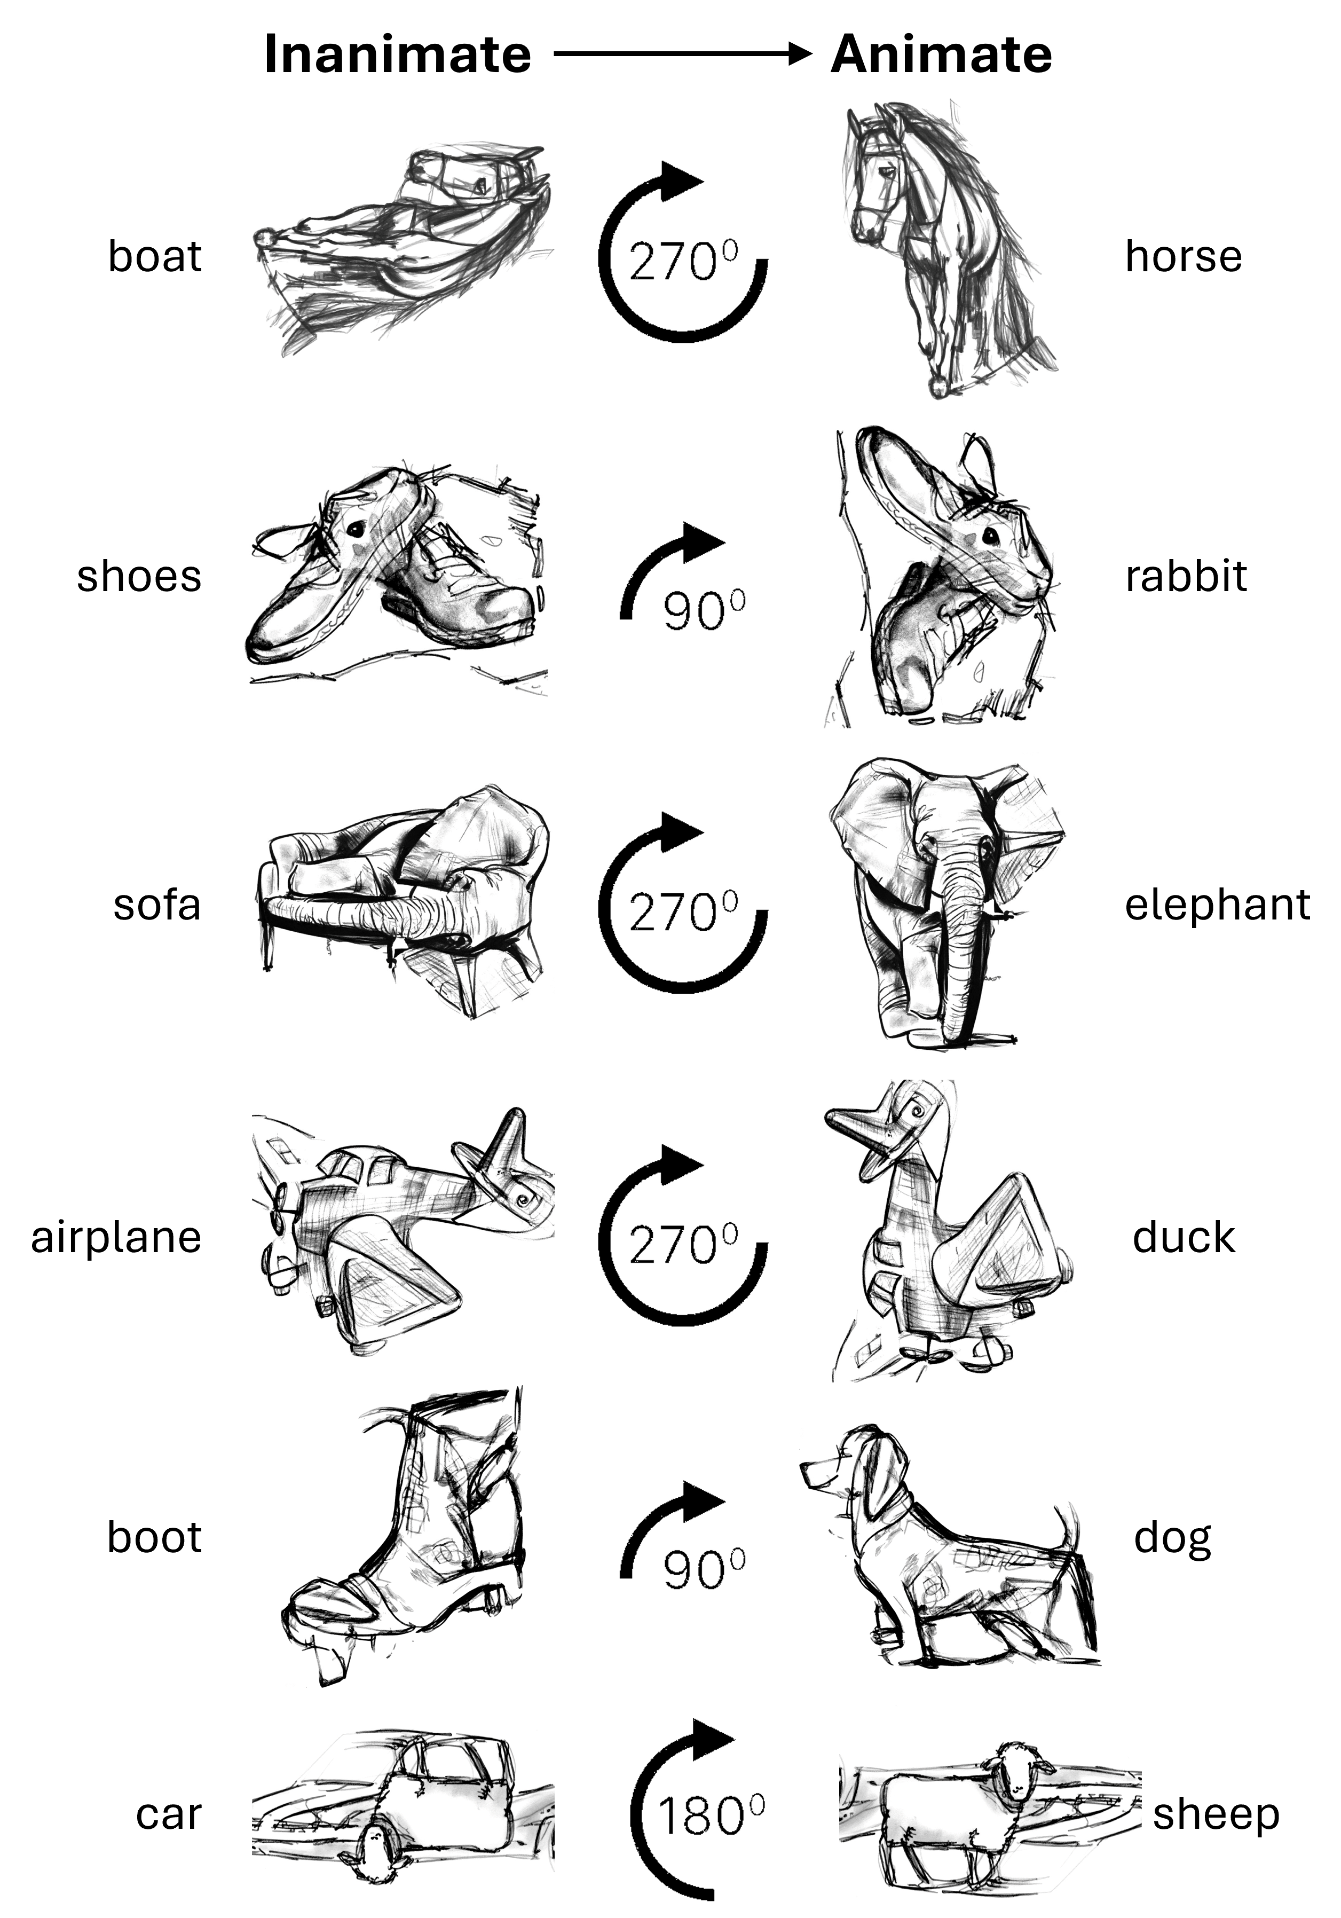
Figure 1. Overview of the six pairs of “visual anagrams” used by Bogers & Firestone (2026). Each inanimate object (left) can be rotated to produce an animate object (right).

References
Barbot, A., Xue, S., & Carrasco, M. (2021). Asymmetries in visual acuity around the visual field. Journal of Vision, 21(1), 2.
Benson, N. C., Kupers, E. R., Barbot, A., Carrasco, M., & Winawer, J. (2021). Cortical magnification in human visual cortex parallels task performance around the visual field. eLife, 10, e67685.
Boger, T., & Firestone, C. (2026). Perceiving animacy in ‘identical’ images. eLife, 15, RP111179.
Boger, T., & Firestone, C. (2025). Visual anagrams reveal high-level effects with ‘identical’ stimuli. Current Biology, 35(19), R910-R912.
Cheong, S. K., Tailby, C., Solomon, S. G., & Martin, P. R. (2013). Cortical-like receptive fields in the lateral geniculate nucleus of marmoset monkeys. The Journal of Neuroscience, 33(16), 6864-6876.
de Haas, B., Schwarzkopf, D. S., Alvarez, I., Lawson, R. P., Henriksson, L., Kriegeskorte, N., & Rees, G. (2016). Perception and processing of faces in the human brain is tuned to typical feature locations. Journal of Neuroscience, 36(36), 9289-9302.
Flounders, M. W., González-García, C., Hardstone, R., & He, B. J. (2019). Neural dynamics of visual ambiguity resolution by perceptual prior. eLife, 8, e41861.
Jolicoeur, P. (1985). The time to name disoriented natural objects. Memory & cognition, 13(4), 289-303.
Judd, C.M., Westfall, J., & Kenny, D.A. (2012). Treating stimuli as a random factor in social psychology. Journal of Personality and Social Psychology, 103, 54–69.
Kriegeskorte, N., Mur, M., & Bandettini, P. (2008), Representational similarity analysis—Connecting the branches of systems neuroscience. Frontiers in Systems Neuroscience, 2, 4.
Kupers, E. R., Benson, N. C., Carrasco, M., & Winawer, J. (2022). Asymmetries around the visual field: From retina to cortex to behavior. PLOS Computational Biology, 18(1), e1009771.
Lawson, R., & Jolicoeur, P. (1998). The effects of plane rotation on the recognition of brief masked pictures of familiar objects. Memory & Cognition, 26, 791–803.
Levin DT, Takarae Y, Miner AG, Keil F. 2001. Efficient visual search by category: Specifying the features that mark the difference between artifacts and animals in preattentive vision. Perception & Psychophysics 63:676–697.
Linde-Domingo, J., Ortiz-Tudela, J., Völler, J., Hebart, M. N., & González-García, C. (2026). Determinants of visual ambiguity resolution. Communications Psychology, 4, 78.
Long B, Störmer VS, Alvarez GA. 2017. Mid-level perceptual features contain early cues to animacy. Journal of Vision 17:20.
Passaglia, C. L., Troy, J. B., Rüttiger, L., & Lee, B. B. (2002). Orientation sensitivity of ganglion cells in primate retina. Vision Research, 42, 683–694.
Proklova, D., Kaiser, D., & Peelen, M. V. (2016). Disentangling representations of object shape and object category in human visual cortex: The animate–inanimate distinction. Journal of Cognitive Neuroscience, 28(5), 680–692.
Rajaei, K., Mohsenzadeh, Y., Ebrahimpour, R., & Khaligh-Razavi, S.-M. (2019). Beyond core object recognition: Recurrent processes account for object recognition under occlusion. PLOS Computational Biology, 15, e1007001.
Roth, Z. N., Kay, K., & Merriam, E. P. (2022). Natural scene sampling reveals reliable coarse-scale orientation tuning in human V1. Nature Communications, 13, 6469.
Sasaki, Y., Rajimehr, R., Kim, B. W., Ekstrom, L. B., Vanduffel, W., & Tootell, R. B. H. (2006). The radial bias: A different slant on visual orientation sensitivity in human and nonhuman primates. Neuron, 51(5), 661-670.
Schneider, K. A., Richter, M. C., & Kastner, S. (2004). Retinotopic organization and functional subdivisions of the human lateral geniculate nucleus: a high-resolution functional magnetic resonance imaging study. The Journal of Neuroscience, 24(41), 8975-8985.
Tang, H., Buia, C., Madhavan, R., Crone, N. E., Madsen, J. R., Anderson, W. S., & Kreiman, G. (2014). Spatiotemporal dynamics underlying object completion in human ventral visual cortex. Neuron, 83, 736–748.
Wells, G.L., & Windschitl, P.D. (1999). Stimulus sampling and social psychological experimentation. Personality and Social Psychology Bulletin, 25, 1115–1125.
Westfall, J., Judd, C.M., & Kenny, D.A. (2015). Replicating studies in which samples of participants respond to samples of stimuli. Perspectives on Psychological Science, 10, 390–399.
Yarkoni, T. (2022). The generalizability crisis. Behavioral and Brain Sciences, 45, e1.
Yetter M, Robert S, Mammarella G, Richmond B, Eldridge MAG, Ungerleider LG, Yue X. 2021. Curvilinear features are important for animate/inanimate categorization in macaques. Journal of Vision 21:3.

